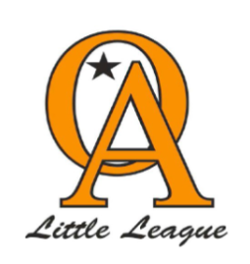
Orcutt American Little League Farm 2024 League Rules

- Home team will set up the field and the visiting team will break down and clean up the field. This included emptying the trash cans. Home team will keep score.

- Every player on the roster will participate for a minimum of 50% of the game and the continuous batting order of all players on the roster will be used. Players cannot sit on the bench for more than one inning in a row.
  - Note the exceptions are as follows:
    - Injured players or those being disciplined, all known exceptions must be noted in the official score book before the start of the game. Player agent must be notified of disciplinary action against the player prior to action being taken. .
- During weekdays the time limit is 1hr and 45 minutes. Saturday's game time limit is 2 hours. No new inning once the time limit has expired.

- 5 run limit per inning except for the final inning (unlimited runs). Managers from both teams playing need to determine the final inning before time expires.

- Live pitching will take effect at the midpoint of the season. Strikes by player/pitcher will be counted. Pitchers will pitch 3 pitches. If after the 3 pitches there is not a hit the coach will pitch 3 more pitches with a total of 6 pitches per batter, unless the player fouls. Refer to Pitching Eligibility for the amount of pitches pitchers can pitch per game.
- Pitching distance for coaches will be noted on field to ensure all teams are pitching from an equal distance. Overhand pitch only.
- 6 year olds are able to pitch if they participated in t-ball the year before.

- If the batter is hit by a pitch of a player he will take first base. If hit by a coach, the ball will be dead and the pitch does not count towards batters six pitches. A pitcher will be removed immediately following the 3rd batter hit by a pitch in one game.

- No more than two bases on any hit. Batter or runner.

- NO STEALING ALLOWED. No stealing on pass balls or overthrows to the pitcher.

- Time permitting six innings will be played.

- The 10 run rule will be imposed on all games after the 4th inning.

- USA BATS ONLY

- Farm win/loss records will not be tracked throughout the season. Year end tournament bracket will be a random draw.
- Championship game no time limit six innings. Run rule will still be in effect.
- Farm:
  - If a ball hit touches infield dirt batter and runner(s) may advance only 1 base
  - If a ball touches outfield grass and not infield dirt, the batter and runner(s) may advance a maximum of 2 bases.
  - An overthrow will allow batter and runner(s) to advance 1 additional base to above rules

